Two Methods for Running Jupyter Notebooks.

In this document two methods for running Jupyter Notebooks are presented. The first method involves downloading and installing Miniconda. The notebook then runs locally on your machine. The second method involves Google Colab. In this method no software is downloaded or installed on your machine, and the notebook is hosted in the cloud.

Instructions for installing Miniconda and Running a Jupyter Notebook on a Windows machine.

Miniconda is a lightweight version of Anaconda which is a distribution of Python. Jupyter notebooks provide an interactive platform for running python code.

In this document:

* Steps to download and install Miniconda
* Setting up a virtual environment
* Steps to download the packages required for ENEL 441
* Steps to run a Jupyter Notebook

Downloading and Installing Miniconda

1. Go to the website: [https://docs.conda.io/en/latest/miniconda.html](https://docs.conda.io/en/latest/miniconda.htmlc) and click on link to download windows 64bit version of the installer:

Run the installer. Make sure you run it locally (this should be the default).

Finish installation using all the defaults.

Click on the Windows Start Menu, open Anaconda Prompt. This should open a window that looks like this:

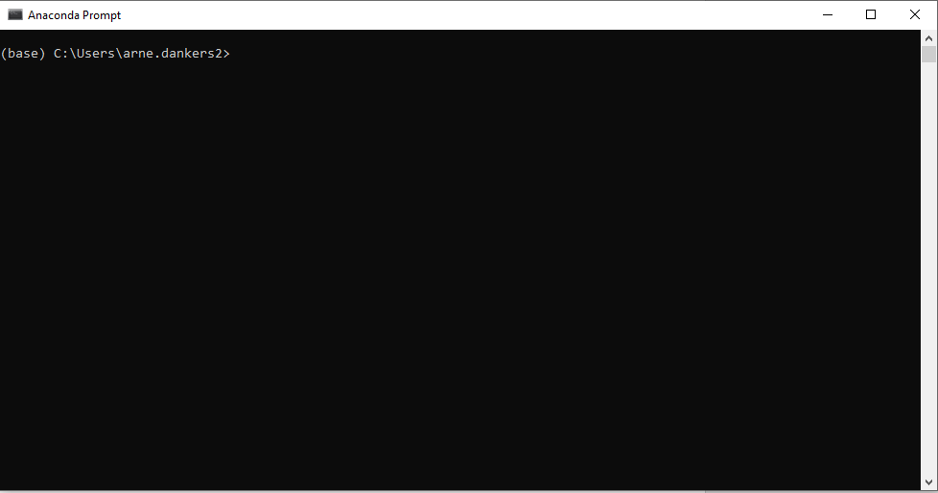

When using Python it is a good idea to create Virtual Environments. This allows you to download different versions for packages in each virtual environment. In the next steps we will create a new virtual environment where we will download all the packages for the ENEL441 course. To do this: at the prompt type in:

>>conda create -n enel441

You will be prompted to proceed, type ‘y’ for yes.

This creates a virtual environment called enel441.

Note that in the screen shot above, I called my virtual environment enel441_2024 because I already have another virtual environment called enel441.

Now we will activate the environment. Type:

>>conda activate enel441

Note that the text in bracket preceding the prompt has changed from ‘base’ to ‘enel441’. This indicates which environment is active.

Now we will install the required packages.

>>conda install numpy jupyter scipy matplotlib

You will be asked to confirm the installation. Type ‘y’ in the prompt.

Plus more text will appear below this.

Wait until you see the following text in the window:

Now install control package:

>>conda install -c conda-forge control

It will print a message about upgrading/downgrading some packages. Just type ‘y’ to accept.

Now we have completed installing the python packages that we will need. In the following steps we will see how to launch a Jupyter Notebook. Make sure the enel441 environment is active.

At the miniconda prompt type:

>>jupyter notebook

This will open a window in your browser. Or it might open a new browser. The browser page will look like:

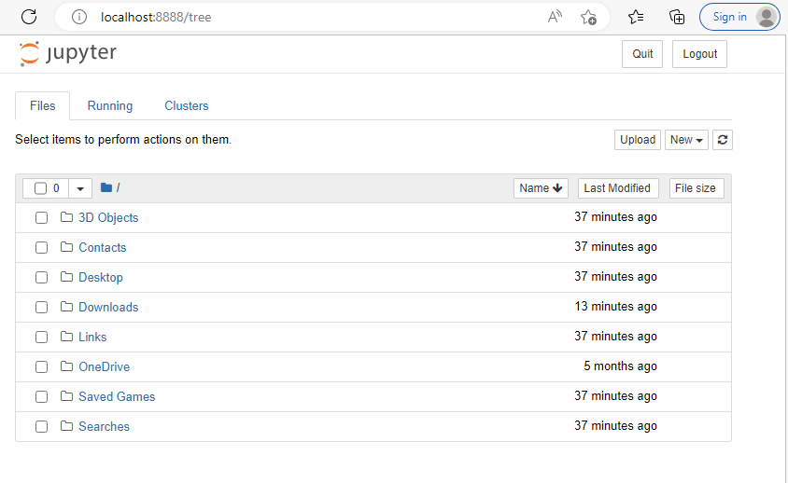

Make a folder. I made one in Documents called ENEL441. Use the mouse to click to the folder you wish to store your notebook:

Then click on the ‘New” button:

And select notebook. Then you will be prompted to select a Kernel:

And select Python 3 (ipykernel)

This should start a new notebook. :

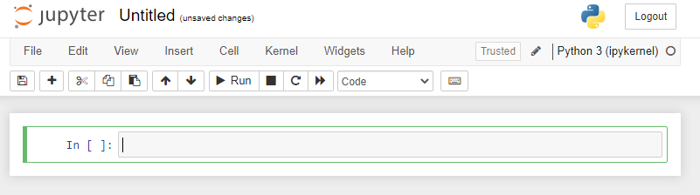

Click on ‘File’ then ‘save as’ to rename and save the file.

You are now ready to run python code in the notebook!

Downloading the lecture notebooks from Git

You will need to download the notebooks for the lectures. To download the files from Github using the anaconda prompt follow these instructions:

At the Anaconda prompt, activate the enel441 virtual environment (if it is not already active):

>> conda activate enel441

Then change the directory to where you want the files to be downloaded. You can make a new directory using the mkdir command. Then use the cd command to go to that directory:

Now we will clone the git repository. Cloning a repository essentially means downloading the files from the repository to the directory you specified:

>>git clone https://github.com/arneUofC/Unit-1---modelling-and-representations

Now in my File Explorer, I see that a new folder has been created in ENEL441:

In this folder you will find the contents of the repository, including the notebook files that we will use during lectures. Notebook files have extensions .ipynb.

You can now launch Jupyter Notebooks (using the instructions above) and open any of the .ipynb files.

Using Google Colab

Google Colab allows you to connect to a GitHub repository and run the notebooks in the repo. Colab is hosted in the cloud by Google. The advantage of running notebooks in this way is that you do not need to install or download any software.

Go to the Google Colab website: <https://colab.research.google.com/>

You will see a welcome screen:

Click on File -> open notebook. A popup will appear:

Click on the GitHub tab.

In the GitHub URL enter https://github.com/arneUofC/Unit-1---modelling-and-representations

You should see all the files in the repo:

Find the file ‘Unit 1 – Modelling and Simulation in Time Domain.ipynb’

Click on it to open it.

You should see:

